**OUTPUT IMAGES**

1. user button and hold it for two seconds [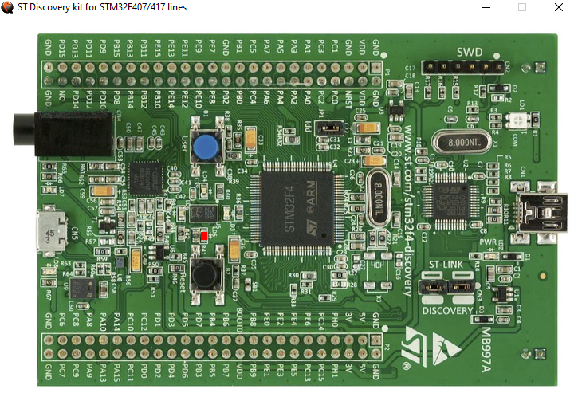](https://user-images.githubusercontent.com/101312396/168205845-9855cb85-3c2a-49ee-9e32-86cdc944a7c0.png)
2. WIPER SPEED LOW [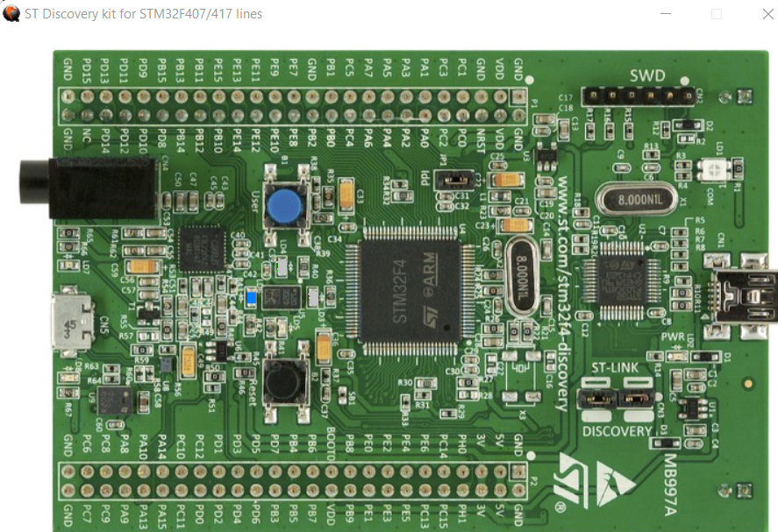](https://user-images.githubusercontent.com/101312396/168206233-b2fbccf2-1df2-4b97-9127-4e99626506cd.png)
3. WIPER SPEED MEDIUM

[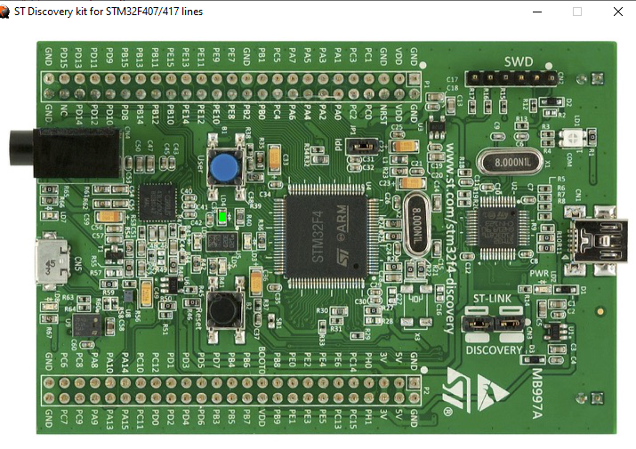](https://user-images.githubusercontent.com/101312396/168206571-cfa61e88-18c1-4db7-a97f-23284b343cbe.png)

1. WIPER SPEED IS HIGH [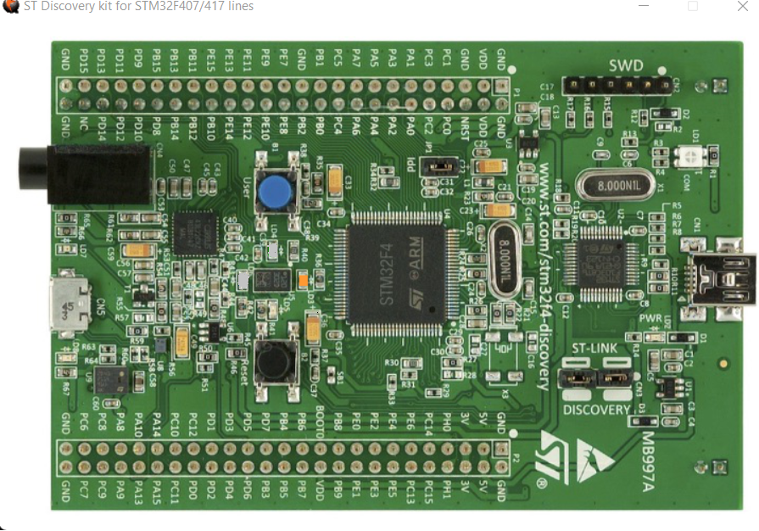](https://user-images.githubusercontent.com/101312396/168206810-c69e4b0d-28b0-4ef4-8191-a3806236dbae.png)
2. user button is pressed and held for 2 seconds, the red LED is off [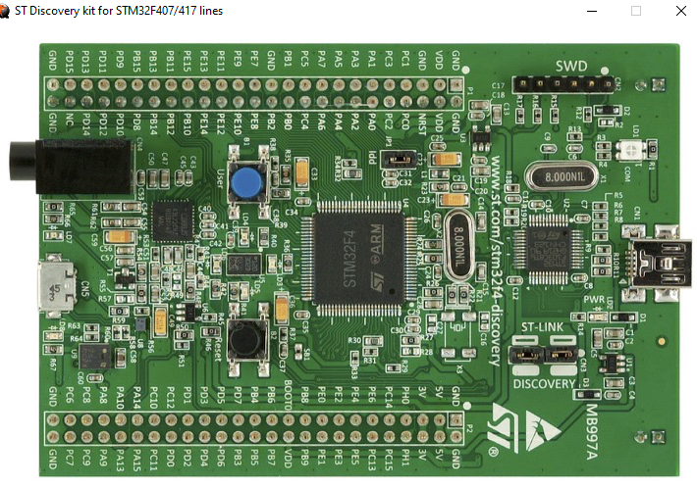](https://user-images.githubusercontent.com/101312396/168207080-f499c980-b029-48a1-becf-b28a336b77ce.png)